Institutional Agreement to Participate
Washington State-Funded Financial Aid Programs
Passport to College Promise for Foster Youth Addendum
This contract is made and entered into by and between the state of Washington, Washington Student Achievement Council, PO Box 43430, Olympia, WA 98504-3430, hereafter referred to as “WSAC” or “AGENCY”, and the below named firm, hereinafter referred to as “CONTRACTOR” or “INSTITUTION”.
Institution Name
Street Address
City, State Zip
Phone:
Fax:
Email:
Federal TIN:
WA State UBI Number:
- Purpose
The purpose of this Agreement is to outline the responsibilities of the WSAC and the INSTITUTION in implementing the Passport to College Scholarship Program’s Institutional Incentive Grant program for supporting Passport to College eligible students. This work will be conducted through the INSTITUTION’s Viable Plan pursuant to RCW 28B.117 and WAC 250-83-060.
- Statement of Work
- Responsibilities of the Institution
The Passport to College program establishes that qualified institutions must agree to the following conditions in order to receive incentive grant payments from the WSAC for the successful recruitment and retention of Passport eligible students.
- Viable Plan: The INSTITUTION agrees to design and implement a viable plan to deliver specialized support services to promote and increase access, persistence and completion of postsecondary education. The plan is created by the INSTITUTION, but should follow the outline included in Appendix A and will be submitted to WSAC for review and approval. Although not required, the INSTITUTION is highly encouraged to review the Viable Plan annually to make modifications to their plan as needed to most effectively serve Passport eligible students.
- Identification: The INSTITUTION must include on their application for admission or registration materials a question asking a student to self-disclose whether they were in state, tribal, or federal foster care in Washington state. The question may be used for the purpose of delivering support services and awarding financial aid and will be shared with the INSTITUTION’s Passport Designated Support Staff (DSS). Additionally, campuses are encouraged to develop other identification strategies so that all eligible students on campus are engaged. It may not be used in consideration for admission to the INSTITUTION.
- Collecting Student Consents:
  - Student eligibility – If the INSTITUTION has identified a former foster youth who is not in the Passport Eligibility Checker in the WSAC Portal, it should provide a Consent Form to the student and forward it to the AGENCY for the purpose of determining program eligibility.
  - Support services – After a student has been determined eligible for Passport, they will receive a Conditions of Award form from the AGENCY. By signing the form, they agree to outreach and support services. INSTITUTIONS may collect the Conditions of Award form and post student Release of Information to the WSAC Portal. A copy of the Conditions of Award form must remain in the student’s file.

- Verifying Eligibility: Verify Passport student eligibility electronically through the WSAC Portal. This verification shall suffice for documentation of foster care and independent status for the purpose of financial aid packaging and support services.

- Leadership Commitment: Create a lasting institutional commitment to serve current and former foster youth by designating a president, chancellor, vice-president, or other position of leadership to advocate and take responsibility for the program’s success.
INSTITUTIONS may also identify an additional person in a leadership role who oversees the operations of the program and assists the Passport Designated Support Staff to remove barriers for successful program implementation.

Leader Name:
Title:
Email:
Phone:

- Designated Campus Support Staff. Designate a knowledgeable “home base” staff person who can direct youth in the areas of financial aid, academic guidance, personal issues, and career counseling/advising. See Appendix B for a Designated Support Staff Job Description example. The designated staff person will also be responsible for preparing campus personnel in these areas to assist referred Passport students.

The person listed as the designated support staff is:
Person Name:
Title:
Email:
Phone:

In the event that the Passport designated support staff changes, the INSTITUTION will notify the AGENCY of any designated support staff changes within 30 days.

Designated Financial Aid Staff. Designate a financial aid staff member who can guide and support Passport students through the financial aid process. See Appendix C for a Passport Financial Aid Job Description example.

The person listed as the financial aid support staff is:
Person Name:
Title:
Email:
Phone:

- Connect with Social Services and Independent Living Providers. Work with Supplemental Education and Transition Plan (SETuP) program staff, Department of Children Youth and Families and its contracted Independent Living providers, and other non-profit agencies serving foster youth to ensure students from foster care receive a full-range of support services and other college preparation information. Ensure appropriate releases of information are in place in order to most efficiently serve students.
- Financial Aid. Review each Passport student’s individual budget to recognize the actual living expenses and tailor the financial aid package, to utilize all available resources to meet the student’s full need and minimize reliance on loans.
- Institutional Incentive Funding. The INSTITUTION’s request for scholarship payment signifies satisfactory academic progress has been verified and the student is eligible for the ensuing term. By July 30 of each academic year, the INSTITUTION will submit a report to the AGENCY on the use of the incentive grant funds. Incentive funds should be used to help remove barriers for Passport eligible students. WSAC encourages INSTITUTIONS to use Institutional Incentive funds in the academic year it is received, however, if not all funds are used, the INSTITUTION must provide a plan for future incentive grant use. Incentive funds received must be spent by the end of 2019-2020 academic year (OR expended within two years of receipt).
- Education and Training. To the extent practical, ensure the INSTITUTION’s leadership, financial aid staff and designated support staff participate in training provided by the WSAC or its partner organizations and representatives about the Passport program and related foster youth resources.

- Responsibilities of the Washington Student Achievement Council
- Program Eligibility. WSAC will collect student consent through the Free Application for Federal Student Aid (FAFSA), Common Application, and Passport Consent Form. WSAC will work with Department of Children Youth and Families to determine student eligibility for the Passport to College Scholarship program.
- Secure Portal. Student-level data will be maintained in the WSAC’s secure Portal for Department of Children Youth and Families and INSTITUTION eligibility processing.
- Reports. WSAC will collect student level data from INSTITUTIONS and compose program reports.
- Verification of Eligibility. Student eligibility will be verified with Department of Children Youth and Families. The AGENCY will notify students of their eligibility status via mail or through electronic means. Students determined ineligible for Passport are provided with information on alternative sources of aid and support services. Student eligibility will be provided to the institution securely through the WSAC’s portal.
- Scholarship Payment Disbursement. The AGENCY will disburse Passport Scholarships through the WSAC Portal. Student quarters of eligibility remaining (QER) for Passport will be tracked. The AGENCY will review systems annually to ensure that ineligible “aged out” Passport students are reported accurately in the portal for institutions to review. Repayment will be coordinated for those students who receive Passport funds and then become ineligible for funding.
- Training. The AGENCY will provide trainings and technical assistance.
- Provide timely customer service to students, institutional financial aid, and designated support staff.
- Provide one-on-one Portal training to institutional staff as requested.
- Provide annual training to institutional financial aid administrators on programs administered by the AGENCY and contribute to trainings provided by organizations contracted to provide Passport services.
- Provide students with financial aid resources. Direct students to appropriate campus staff for support services. Provide referrals to contractor for intervention in emergency situations.

- Consideration
Incentive Grant Payments to Institution
Incentive grants are provided to the INSTITUTION for the recruitment and retention of eligible students. Grants shall be used for individualized student support services which may include, but are not limited to, college and career advising, counseling, tutoring, costs incurred for students while school is not in session, personal expenses, health insurance, and emergency services.
Each party herein constitutes the consideration for this agreement. The amount of an incentive grant payment will be determined annually by the AGENCY based on program appropriations.
Incentive grant disbursements will be made each term after the INSTITUTION verifies the student’s enrollment by requesting the student’s Passport scholarship payment. The AGENCY will disburse incentive grant funds for each student who successfully enrolled in and completed the term.

- Term
This addendum becomes effective on the date executed by the WSAC and will expire on June 30, 2020, or sooner if terminated by one or both parties in writing.
- Reporting
The INSTITUTION shall produce the following written reports or other written documents (deliverables) on the report template provided by WSAC by the dates indicated below:
July 31, 2019 (for effective date of contract through June 30, 2019)
- Termination
This agreement may be terminated immediately by mutual consent of all parties, or by either party upon 30-day written notice and delivered to the other party by certified mail or in person.
- Certification and Execution of Passport Addendum
I hereby certify that I am an officer of the INSTITUTION legally authorized to execute this Passport to College for Foster Youth Addendum to the Institutional Agreement for and on behalf of the INSTITUTION and certify that to the best of my knowledge and belief, all information in this document are true and correct.

Institution

Authorized Official

Name (typed or printed)

Title

Date

Washington Student Achievement Council

Director of Student Financial Assistance

Name (typed or printed)

Title

Date

APPENDIX A – Passport Viable Plan Template
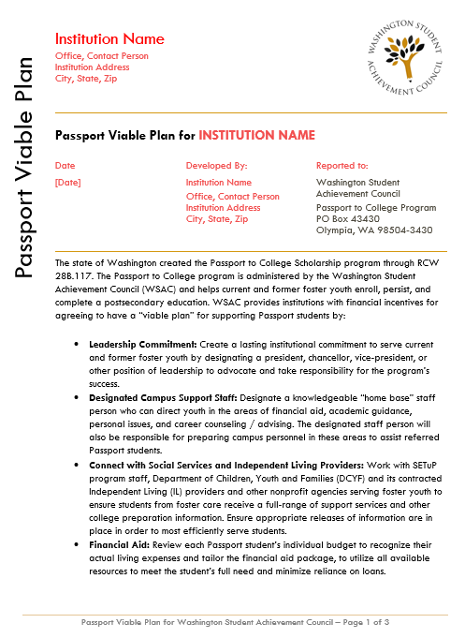

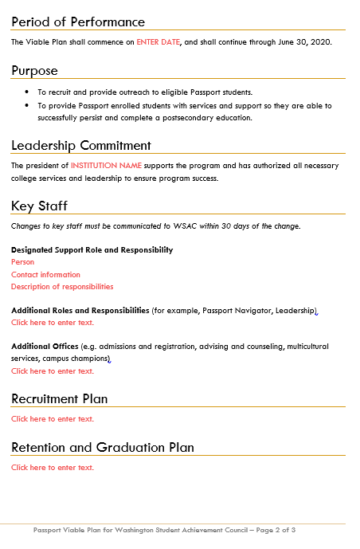
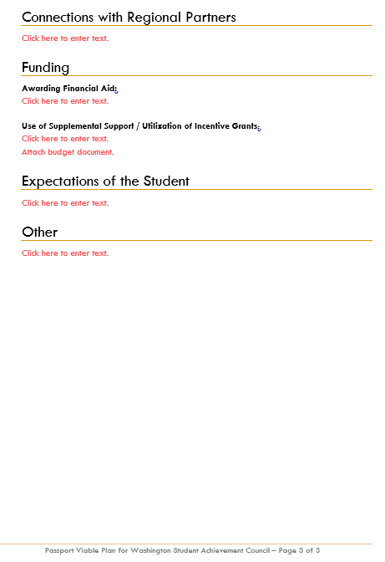
APPENDIX B – Designated Support Staff Job Description

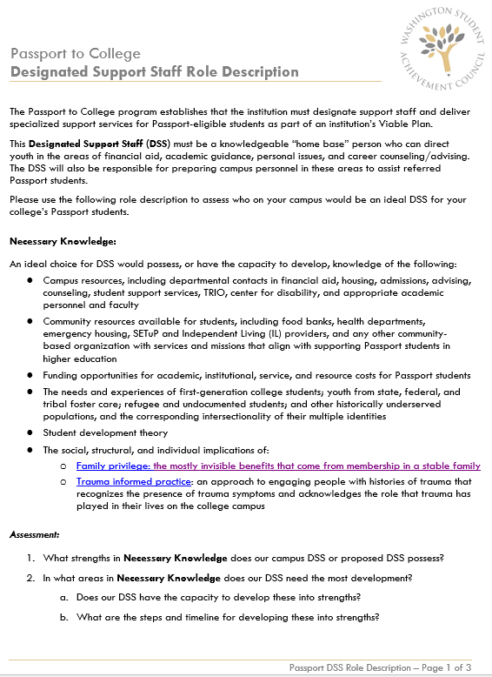

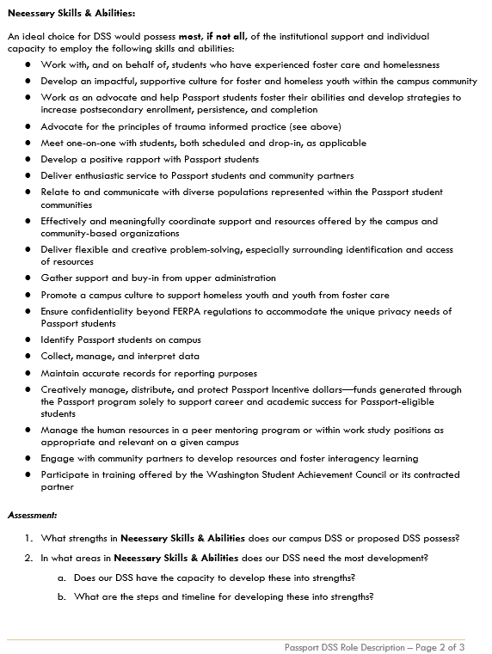
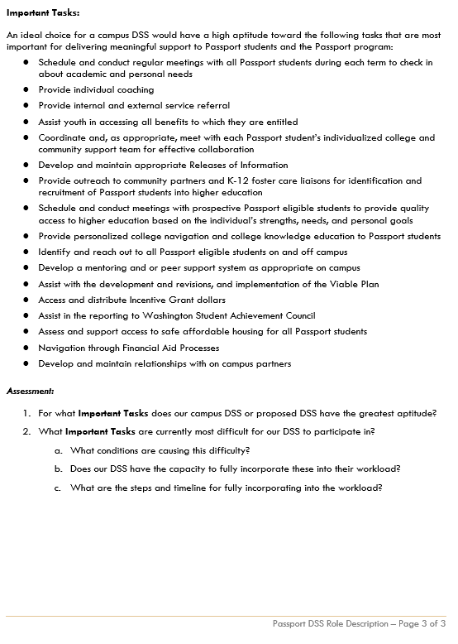
APPENDIX C – Financial Aid Administrator Job Description
