Central Washington University  AAP, Debra Lewis  400 East University Way  Ellensburg, WA 98926 | 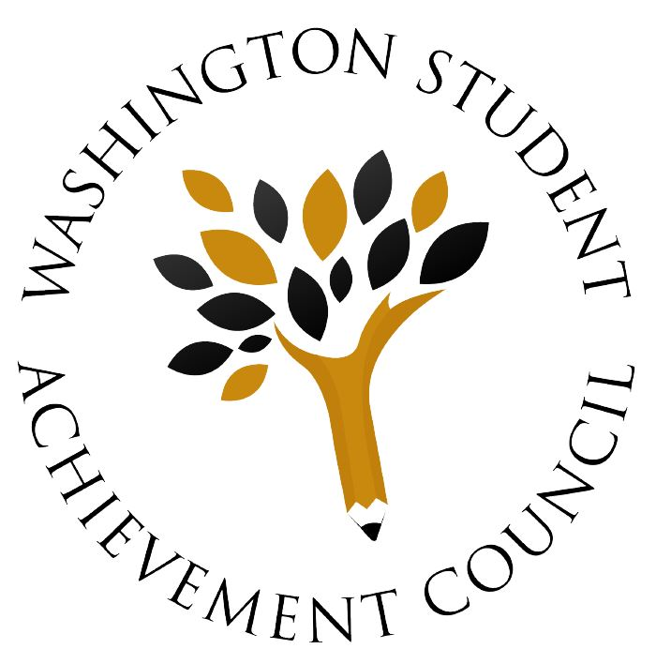
  - Passport Viable Plan for INSTITUTION NAME

Passport Viable Plan
Date | Developed By: | Reported to:
August 15, 2018 | Central Washington University  AAP, Debra Lewis  400 East University Way  Ellensburg, WA 98926 | Washington Student Achievement Council  Passport to College Program  PO Box 43430  Olympia, WA 98504-3430
The state of Washington created the Passport to College Scholarship program through RCW 28B.117. The Passport to College program is administered by the Washington Student Achievement Council (WSAC) and helps current and former foster youth enroll, persist, and complete a postsecondary education. WSAC provides institutions with financial incentives for agreeing to have a “viable plan” for supporting Passport students by:
- Leadership Commitment: Create a lasting institutional commitment to serve current and former foster youth by designating a president, chancellor, vice-president, or other position of leadership to advocate and take responsibility for the program’s success.
- Designated Campus Support Staff: Designate a knowledgeable “home base” staff person who can direct youth in the areas of financial aid, academic guidance, personal issues, and career counseling / advising. The designated staff person will also be responsible for preparing campus personnel in these areas to assist referred Passport students.
- Connect with Social Services and Independent Living Providers: Work with SETuP program staff, Department of Children, Youth and Families (DCYF) and its contracted Independent Living (IL) providers and other nonprofit agencies serving foster youth to ensure students from foster care receive a full-range of support services and other college preparation information. Ensure appropriate releases of information are in place in order to most efficiently serve students.
- Financial Aid: Review each Passport student’s individual budget to recognize their actual living expenses and tailor the financial aid package, to utilize all available resources to meet the student’s full need and minimize reliance on loans.

Period of Performance
The Viable Plan shall commence on July 1, 2018, and shall continue through June 30, 2020.

Purpose
- To recruit and provide outreach to eligible Passport students.
- To provide Passport enrolled students with services and support so they are able to successfully persist and complete a postsecondary education.

Leadership Commitment
The president of Central Washington University supports the program and has authorized all necessary college services and leadership to ensure program success. Central Washington University is committed to promoting student success and holistically integrating student supports with a focus on equity for underserved students such as foster and homeless students.

Key Staff
Changes to key staff must be communicated to WSAC within 30 days of the change.
Designated Support Role and Responsibility
Lorinda Anderson
TRIO SSS Program Coordinator
Central Washington University
Lorinda.anderson@cwu.edu

Debra Lewis
AAP Director
Central Washington University
Debra.lewis2@cwu.edu

Role/Responsibilities: The main designated support for passport scholars at CWU. Supportive roles include meeting with students regularly for academic advising and support, coordinating with other departments and community/social service agencies to provide wrap-around support for students, serving as the main point of contact for students for any issues that arise related to barriers they are facing academically, personally, mentally, and physically.
- Additional Roles and Responsibilities (for example, Passport Navigator, Leadership)
CWU Graduate Assistant
- Additional Offices (e.g. admissions and registration, advising and counseling, multicultural services, campus champions)
Dr. Aaron Brown-Associate Dean of Student Success; Kelley Christianson, CWU Financial Aid Office; and Heather Harrell CWU budget management office.

Recruitment Plan

Central Washington University recruits students through many different avenues both on campus and off campus.
Goal/Objective: The designated support staff will work closely with different departments (advising, TRIO, admissions, athletics) to coordinate recruitment efforts. CWU passport program will develop an online platform and webpage for the recruitment of potential participants, post flyers and bring promotional materials to on campus events, fairs, and orientations.
The goal will be for the Passport team to build a strong relationship with other departments so they are able to connect with potential eligible passport students.
Plan of Action (POA):
- Meeting with students through on-campus visits and activities: Throughout academic year and CWU sponsored events.
Proposed timeline fall (September-Late November) and spring follow-up (Feb-Late May).
- Connecting with community organizations (Catholic charities, Treehouse, etc.) staff/contacts for visits or admissions advising-including any educational events and or conference events.
- Connecting with Foster Youth Liaison at WA State high schools-Collaborate and communicate in order for consistent contact in the school setting.
Timeline: Fall (September-Late November) and spring follow ups (February-late May).
- Attendance to local events such as a local fair to share and establish contacts (Apply for and connect Passport resources).
- Work with current participants in the program to promote/speak on their experiences as a CWU student with prospective participants-Passport current/alumni students provide stories and experiences that serve as a resource for prospective students and to answer their questions.
Proposed timeline: Students availability during academic school year (September-June)

Retention and Graduation Plan
Goal/Objective: Improve the graduation and progression rate of Passport scholars that matriculate to Central Washington University.

The goal will be to increase the number of scholars that progress from one academic year to the next academic year until college completion.

Metrics (database/tracking): Progression rate of scholars will be tracked through a student-tracking database. This will be a new initiative for the project and I will continue to work on and build this metric throughout the 2018-2019 and 2019-2020 program years.

Program Components:

Intrusive Advising: Course selection and identification of students on academic warning early to coordinate a plan of action with faculty and will include mandatory tutoring or SI sessions. Summer living and learning community (Vincent Tinto)

Supplemental Instruction: Focus on learning important study skills
Orientation:

Program Description:
From July to August, for 3-weeks, incoming passport scholars will take part in a 3-week residential experience at CWU. This 3-week experience will provide new CSF scholars to CWU an amazing on-campus experience with an intensive academic schedule focusing on developmental mathematics, reading, writing, university 101 success seminars, skills workshops and professional development. This experience is invaluable and will be free of charge, providing housing, meals, and the materials needed for courses. Passport scholars that successfully complete the CWU 3-week summer bridge component will have the opportunity to retake their placement exams to earn a higher score. Why is that important? A higher score could save both money and time on tuition, fees, and university requirements! To succeed in the CWU 3-week summer bridge component you are required to give 100% effort and participation in all program activities in preparation for your FIRST year at Central Washington University.

What to Expect:
Weeks 1-3: July-August will be a 100% residential program and will serve as the orientation to the CWU CSF program, the program staff, and the summer curriculum. Participants will be living in a residence hall with other CWU students. During this program and daily, students will learn about student employment opportunities along with social activities.

All participants will be required to take the final placement test for both math and English to complete the program. CSF DSS will meet with participants to complete fall quarter advising and develop and ISP or Individual Success Plan.

When a CSF summer participant moves into the residence hall fall 2019, they will be more confident and connected with a safety net of faculty/staff to guide them through their first year at CWU.

CWU 3-Week Residential Summer Bridge Experience:
- Identify incoming student eligible for passport and coding them to the Foster Youth/Homeless Youth AmeriCorps Advisor and/or CWU graduate Assistant
- Send a postcard to incoming participant to confirm attendance to CWU and discuss financial aid and benefit of the program. Determine whether student is willing to come to campus early for a 3-week summer experience to become acclimated to the CWU environment.
- Placement testing (ALEX): Evaluate test scores to determine development course placement
- Intrusive Advising: Placing them in courses based on assessment results; strengthen weak academic skill areas (English, Writing, Math)
- Daily Tutoring: Hire tutors to work with students to improve course related skills as well as test taking skills
- Developmental Faculty: secure instructors willing to work 1:1 with students to strengthen/build academic skills
- Residential housing: All participants housed together –living/learning community. Build in evening study groups and mandatory library time.
- Food: Meal plan developed utilizing USDA guidelines for healthy meal choices:
Breakfast
Lunch
Dinner
- Evening/Day: activities appropriate for incoming new students

Fall:
- Build on Summer Bridge experience with participants through intrusive advising and determining course schedules for fall.
- Identify and work with non-bridge participants or those students eligible for passport and coding them to the Foster Youth/Homeless youth AmeriCorps staff and graduate assistant
- Meet with students during orientation: send a postcard inviting them to meet in the AAP/CSF offices for a welcome event.
- Meet with continuing students to discuss financial aid eligibility/documentation
- Develop individual academic plan at the beginning of the quarter with the graduate assistant/ this should be a one-hour meeting and take place first two weeks of the quarter to build rapport, discuss academic plans, financial aid, and to connect them with campus resources.
- Connect scholar with the appropriate academic adviser through TRIO, STAR, or the advising office.
- Connect them with Financial Aid and monetary resources available for them such as funding for books, supplies, bedding, clothing, food, toiletries, etc.

Winter:
- Annual Winter Warmth event-warm coats and winter gear purchased at local store with program graduate assistant or AmeriCorps
- Career services workshops and events available for CWU students
- Social and cultural activities
- Graduate school exposure events

Spring:
- Community/Volunteer activities with CWU GA or AmeriCorps
- Job shadowing experience (on/off campus)

Each Quarter:
- Participants must meet with graduate assistant at least two times each quarter for check-in and to discuss progress, goals for the quarter, celebrate successes, and address student concerns.
- Introduce the early alert system to identify students not making academic progress, not attending classes, keeping up with work, isolation, and making progress towards goals and degree completion.
- Communicating with financial aid liaison for student concerns re: financial aid/funding
- Coordinating quarterly events to meet CSF goals
- Participating in early career exploration activities
- Filing FAFSA/WASFA –October
- Engaging in extracurricular activities
- Meeting with faculty
- Attending advising appointments

Connections with Regional Partners
The DSS holds a leadership position in this community and will continue to attend these meeting in 2019 for professional development and to understand how best to serve passport scholars.

Goal: Continue to attend meetings to leverage position and to grow partnership for foster/homeless youth.

- Treehouse
- Catholic Charities
- Ellensburg Public Schools
- College Success Foundation
- Yakima Community College
- Education Training Voucher (ETV)

Funding
Awarding Financial Aid:
Identifying and confirming eligible students
- Utilizing WSAC portal
- Communicate with CWU financial aid team on eligible students
- Follow-up with students to ensure all documentation is complete
- Prioritize Passport eligible students for financial aid
- Notify/confirm students of other financial aid eligibility
- Serve as liaison for students/support staff who have financial aid concerns/issues
Use of Supplemental Support / Utilization of Incentive Grants:
Click here to enter text.
Attach budget document.

Expectations of the Student
- Meet academic advisor at least twice per quarter
- Meet with faculty advisor
- Attend career workshops and seminars
- File FAFSA/WASFA by due date
- Participate in extracurricular activities
- Participate in Health/Wellness events
- Attend tutoring sessions or SI

Other
Additional Goals:
- Make sure every eligible student receives funding enrolled at CWU to cover COA, Housing, Books, Supplies, etc.
- Make CWU a conference hub for foster care in the Central Valley area.
- Staff Professional development through attendance to the Passport Conference in May.
- Ongoing Professional Development
- Utilize funds for speaker Series for scholars
- Develop meaningful programing for scholars to spend down incentive funds given to CWU for passport students

