
Institutional Agreement to Participate
Washington State-Funded Financial Aid Programs
Passport to Careers Addendum
This agreement is made and entered into by and between the State of Washington, Washington Student Achievement Council, PO Box 43430, Olympia, WA 98504-3430, hereafter referred to as “WSAC” or “AGENCY”, and the below named firm, hereinafter referred to as “CONTRACTOR” or “INSTITUTION”.

Institution Name
Street Address
City, State, Zip
Phone
Fax
Email
Federal TIN
WA State UBI Number

- Purpose
The Passport to Careers program helps youth who have experienced either foster care or unaccompanied homelessness prepare for and succeed in college, apprenticeships, or pre-apprenticeship programs. Under the Passport to Careers Program, there are two subprograms:
- Passport to College
- Passport to Apprenticeship Opportunities
The purpose of this Agreement is to outline the responsibilities of the WSAC and the INSTITUTION in implementing the Passport to College program’s Student Support Fund payments (formerly called Institutional Incentive Grant) for supporting Passport to College eligible students. This work will be conducted through the INSTITUTION’s viable Passport Student Support Plan (formerly referred to as the Passport Viable Plan) pursuant to RCW 28B.117 and WAC 250-100
- Statement of Work
- Responsibilities of the Institution
The Passport to College program establishes that qualified institutions must agree to the following conditions in order to receive Passport Student Support payments from WSAC for the successful recruitment and retention of Passport eligible students.
- Student Support Plan: The INSTITUTION agrees to design and implement a viable plan to deliver specialized support services to promote and increase access, persistence and completion of a postsecondary education. The plan is created by the INSTITUTION but should follow the outline included in Appendix A and will be submitted to WSAC for review and approval. The INSTITUTION is highly encouraged to review the Student Support Plan annually to make modifications to their plan as needed to most effectively serve Passport eligible students.

- Identification: The INSTITUTION must include on their application for admission or registration materials a question asking a student to self-disclose whether they were in state, tribal, or federal foster care in Washington state, or experienced unaccompanied homelessness. The question may be used for the purpose of delivering support services and awarding financial aid and will be shared with the INSTITUTION’s Passport Designated Support Staff (DSS). Additionally, campuses are encouraged to develop other identification strategies so that all eligible students on campus are engaged. It may not be used in consideration for admission to the INSTITUTION.

- Student Eligibility: If the INSTITUTION has identified a former foster youth who is not in the WSAC Portal, it should provide a Consent Form to the student and forward it to the AGENCY for the purpose of determining program eligibility. If the student was in tribal foster care, the INSTITUTION should also provide the student with a Tribal Verification Form.
The INSTITUTION will determine eligibility for students experiencing unaccompanied homelessness. In difficult to determine cases, the INSTITUTION may refer the student to WSAC for eligibility determination. The INSTITUTION may elect to have students who have experienced unaccompanied homelessness complete the Passport Housing Questionnaire to help determine eligibility.

- Verifying Eligibility: Verify Passport student eligibility electronically through the WSAC Portal. This verification shall suffice for documentation of the student’s program eligibility as well as their independent status for the purpose of financial aid packaging and support services. When processing unaccompanied homeless youth, financial aid administrators will post the student’s eligibility to the WSAC Portal.

- Leadership Commitment: Create a lasting institutional commitment to serve current and former foster youth and students who have experienced unaccompanied homelessness by designating a president, chancellor, vice-president, or other position of leadership to advocate and take responsibility for the program’s success.

INSTITUTIONS should identify an additional person in a leadership role who oversees the operations of the program and assists the Passport Designated Support Staff to remove barriers for successful program implementation. A role description for the Passport Campus Leader is in Appendix B.

The person listed as the Passport Campus Leader is:
Leader Name
Title
Email
Phone

In the event that the Passport designated campus leader changes, the INSTITUTION will notify the AGENCY in writing via email of the change within 30 days. Email may be sent to passport@wsac.wa.gov.

- Designated Campus Support Staff. Designate a knowledgeable “home base” staff person who can direct students in the areas of financial aid, academic guidance, personal issues, and career counseling/advising. The designated staff person will also be responsible for preparing campus personnel in these areas to assist referred Passport students. A role description for the Designated Campus Support Staff is included in Appendix C.

The person listed as the designated support staff is:
Person Name
Title
Email
Phone

In the event that the Passport designated support staff changes, the INSTITUTION will notify the AGENCY in writing via email of the change within 30 days. Email may be sent to passport@wsac.wa.gov.

Designated Financial Aid Staff. Designate a financial aid staff member who can guide and support Passport students through the financial aid process. A role description for the Passport Financial Aid Staff is included in Appendix D.

The person listed as the financial aid support staff is:
Person Name
Title
Email
Phone

In the event that the Passport designated financial aid staff changes, the INSTITUTION will notify the AGENCY in writing of the change within 30 days. Email may be sent to passport@wsac.wa.gov.

- Connect with Social Services Providers. Work with Department of Children Youth and Families social service providers and its contracted Independent Living providers, AGENCY contracted SETuP case managers, and other non-profit agencies serving youth who have experienced foster care or unaccompanied homelessness to ensure youth receive a full-range of support services and other college preparation information. Ensure appropriate releases of information are in place in order to most efficiently serve students.

- Financial Aid. Review each Passport student’s individual budget to recognize the actual living expenses, and tailor the financial aid package to utilize all available resources to meet the student’s full need and minimize reliance on loans.

- Passport Student Support Funds (formerly known as Institutional Incentive Grants). The INSTITUTION’s request for scholarship payment signifies satisfactory academic progress has been verified and the student is eligible for the ensuing term.
By August 30 of each academic year, the INSTITUTION will submit a report to the AGENCY on the use of the Passport Student Support Funds. Funds should be used to help remove barriers for Passport eligible students. WSAC encourages INSTITUTIONS to use Student Support funds in the academic year it is received. Student Support funds received must be expended within two years of receipt. If unspent funds remain, the INSTITUTION will provide a plan for future Student Support Fund use.
- Education and Training. To the extent practical, ensure the INSTITUTION’s leadership, financial aid staff and designated support staff participate in training provided by the WSAC or its partner organizations about the Passport program and related foster care and unaccompanied homeless youth resources.

- Responsibilities of the Washington Student Achievement Council
- Program Eligibility. WSAC and the Department of Children, Youth and Families will enter into a data sharing agreement to identify state foster youth meeting Passport program eligibility. In serving federal foster youth and tribal foster youth, WSAC will work with the Department of Social and Health Services and Washington’s Federally Recognized tribes to determine student eligibility for the Passport to College Scholarship program.

- Collecting Consent. WSAC will collect student consent through the Free Application for Federal Student Aid (FAFSA), WASFA, Common Application, Passport Consent Form, and Student Housing Questionnaire.

- Secure Portal. Student-level data will be maintained in the WSAC’s secure Portal for eligibility processing by state agency partners and INSTITUTIONS. The INSTITUTION must use the portal to provide secure electronic communication that contains a student’s personally identifiable information.

- Reports. WSAC will collect student level data from INSTITUTIONS and compose program reports.
- Student Lists. At least annually, WSAC will provide INSTITUTIONS with a list of students determined eligible for the Passport to Careers program and has shared an interest in attending a college on their federal financial aid application. This list is shared with both the Passport Financial Aid Administrator for aid packaging, and the Passport Designated Support Staff for outreach and support. Institutions may request the list from WSAC on a quarterly basis, or more frequently, as needed.
- Verification of Eligibility. Student eligibility will be verified with the Department of Children Youth and Families, Washington’s federally recognized tribes, the Department of Social and Health Services and INSTITUTIONS. The AGENCY will notify students of their eligibility status through electronic means. Students determined ineligible for Passport are provided with information on alternative sources of aid and support services. Student eligibility will be provided to the institution securely through the WSAC’s portal.
- Scholarship Payment Disbursement. The AGENCY will disburse Passport Scholarships through the WSAC Portal. Student quarters of eligibility remaining (QER) for Passport will be tracked. The AGENCY will review systems annually to ensure that ineligible “aged out” Passport students are reported accurately in the portal for institutions to review.
- Training. The AGENCY will provide trainings and technical assistance.
- Provide timely customer service to students, institutional financial aid, and designated support staff.
- Provide one-on-one Portal training to institutional staff as requested.
- Provide annual training to institutional financial aid administrators on programs administered by the AGENCY and contribute to trainings provided by organizations contracted to provide Passport services.
- Provide students with financial aid and other resources. Direct students to appropriate campus staff for support services. Provide referrals to contractor for intervention in emergency situations.

- Consideration
Passport Support Fund Payments to Institution
Passport student support funds are payments to institutions based on recruitment, retention, and support of Passport eligible students. The payment is available only to institutions agreeing to provide specified student support services outlined in this agreement. Institutional participation in the Passport student support fund is voluntary. An otherwise eligible student can receive a Passport scholarship to attend an eligible college even if the institution does not participate in the Passport student support fund option. Each party herein constitutes the consideration for this agreement. To the extent that funds are allocated for this purpose, the amount of Passport student support fund payments to the INSTITUTION will be reviewed and determined annually by the AGENCY based on projected enrollments, appropriations and other relevant factors.
Passport Student Support Fund disbursements will be made each term after scholarship payments have been disbursed and reconciled by the INSTITUTION. A scholarship payment request by the INSTITUTION verifies the student’s enrollment. The AGENCY will disburse Student Support Funds for each student who successfully enrolled in and completed the term.
- Term
This addendum becomes effective on the date executed by the WSAC and will expire on June 30, 2024, or sooner if terminated by one or both parties in writing.
- Reporting
The INSTITUTION shall produce Passport Student Support Fund reports or other deliverables on a template provided by WSAC by the dates indicated below:
- August 30, 2023 (for effective date of contract through June 30, 2023)
- August 30, 2024 (for July 1, 2023 through June 30, 2024)

- Termination
This agreement may be terminated immediately by mutual consent of all parties, or by either party upon 30-day written notice and delivered to the other party by certified mail or in person.
- Certification and Execution of Passport Addendum
I hereby certify that I am an officer of the INSTITUTION legally authorized to execute this Passport to Careers Addendum to the Institutional Agreement for and on behalf of the INSTITUTION and certify that to the best of my knowledge and belief, all information in this document are true and correct.
Institution

Authorized Official

Name (typed or printed)

Title

Date

Washington Student Achievement Council

Director of Student Financial Assistance

Name (typed or printed)

Title

Date

Appendix A – Student Support Plan Template

INSTITUTION NAME
Passport to Careers Student Support Plan
2022-2024

The State of Washington created the Passport to Careers program through RCW 28B.117. The Passport to Careers program is administered by the Washington Student Achievement Council (WSAC) and helps current and former foster youth and unaccompanied homeless youth enroll, persist, and complete a postsecondary education, apprenticeship or pre-apprenticeship. WSAC provides institutions with financial incentives for agreeing to have a viable plan for supporting Passport students by:

- Leadership Commitment: Create a lasting institutional commitment to serve current and former foster youth and unaccompanied homeless youth by designating a president, chancellor, vice-president, or other position of leadership to advocate and take responsibility for the program’s success.

- Designated Campus Support Staff: Designate a knowledgeable “home base” staff person who can direct students in the areas of financial aid, academic guidance, personal issues, and career counseling / advising. The designated staff person will also be responsible for preparing campus personnel in these areas to assist referred Passport students.

- Financial aid: Review each Passport student’s individual budget to recognize their actual living expenses and tailor the financial aid package, to utilize all available resources to meet the student’s full need and minimize reliance on loans.

- Connect with Social Services Providers: Work with the Department of Children, Youth and Families (DCYF) and its contracted providers and other non-profit agencies serving foster youth and unaccompanied homeless youth to ensure they receive a full-range of support services and other college preparation information. Ensure appropriate releases of information are in place in order to most efficiently serve students.

Student Support Plan Implementation

This Student Support Plan shall commence on July 1, 2022 and shall continue through June 30, 2024. Institutions may periodically review their Student Support Plan and make modifications as necessary.

Purpose

- To recruit and provide outreach to eligible Passport to Careers students.

- To provide students enrolled in the Passport to Careers program with services and support.

Leadership Commitment

The president of INSTITUTION NAME supports the program and has authorized all necessary college services and leadership to ensure program success. Their work will help build a lasting institutional commitment to serve students who have experienced foster care or unaccompanied homelessness.

Key Staff
Within the context of the Passport to Careers Program

Designated Support Staff Role and Responsibility

Person
Email

Phone number

Description of Responsibilities in Relation to the Passport Program:

Additional Roles and Responsibilities (i.e., Passport Leadership Team, Passport regional team member):

Financial Aid Administrator Role and Responsibility

Person
Email

Phone number

Description of Responsibilities in Relation to the Passport Program:

Additional Roles and Responsibilities:

Campus Leader Role and Responsibility
Person
Email

Phone number

Description of Responsibilities in Relation the Passport Program:

Additional Roles and Responsibilities:

Additional Offices Identified to Serve Passport Students (i.e., admissions and registration, advising and counseling, multicultural services, campus champions)

List other offices on campus that can help with the successful implementation of the Passport Student Support Plan:

Description Collaboration Between Identified Additional Offices:

Description of how collaboration between Passport to Careers and the Supporting Students Experiencing Homelessness pilot program will occur.

Recruitment Plan

Describe plan for recruiting Passport eligible students:

Retention and Graduation Plan
Describe plan for Passport student retention and graduation:

How does the institution measure student success?

Connections with Regional Partners
Describe the plan for working with regional partners (i.e.: social service providers, postsecondary institutions, community-based organizations):

How does the institution measure success for collaborative work with regional partners?

Funding

Awarding Financial Aid:

Use of Supplemental Support / Utilization of Passport Student Support Funds:

Describe how Passport Student Support Funds will be used to implement elements outlined in the Passport Addendum:

Communication Plan
Describe what office will manage the Passport Student Support Funds and how collaboration for budgets and purchasing will occur in a timely manner.

Student Expectations
Outline the institution's expectations of Passport eligible students as it relates to the institution’s Passport student support plan:

Project Change Control Procedure

The following process will be followed if a change to this Student Support Plan is required:

- The designated Project Manager of the INSTITUTION will review the proposed change and determine whether the change is significant enough to submit the request to the WSAC.
- WSAC and the INSTITUTION will mutually agree upon any charges for such implementation, if any.
- Changes must be approved by both parties to authorize implementation of the changes.

Submission of Student Support Plan

2022-2024 Student Support Plans must be submitted to WSAC by September 1, 2022 and may be sent to Passport@wsac.wa.gov.

Updated: INSERT DATE

Appendix B – Passport Campus Leader Role Description
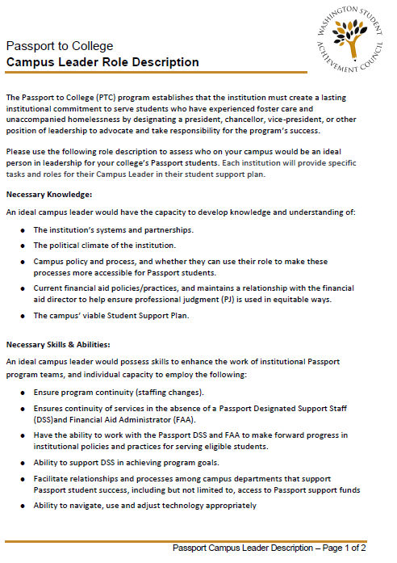
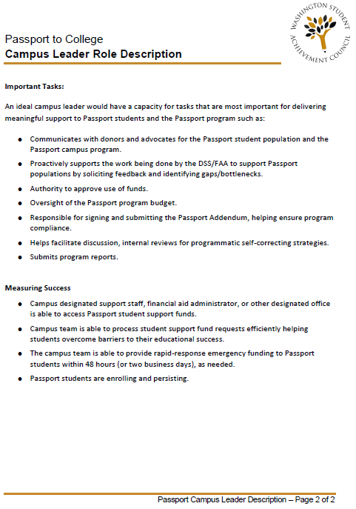
Appendix C – Passport Designated Support Staff Role Description
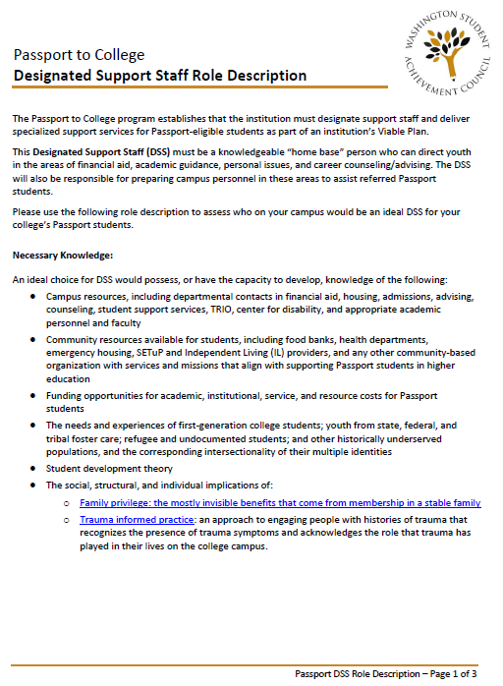
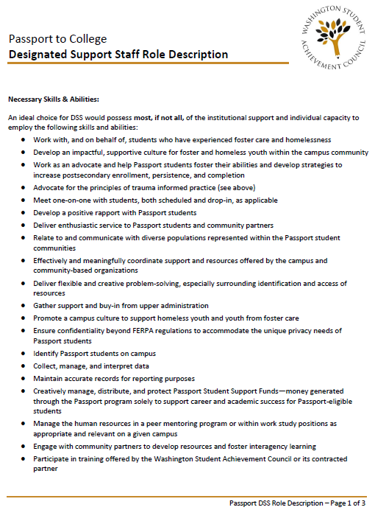
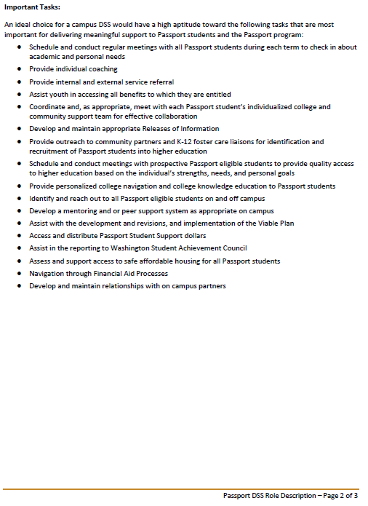
Appendix D – Passport Financial Aid Administrator Role Description
